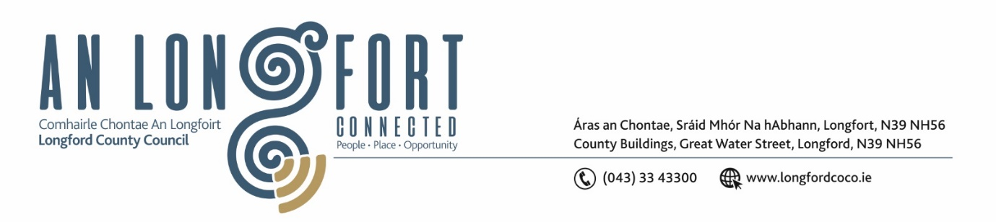

***Please note meeting will be held in the Council Chamber and via Microsoft Teams.***

# 2ú Meán Fómhair 2021.

**Chuig: Gach Ball don Chomhairle.**

A Chomhairleoir,

Iarrtar ort bheith i láthair ag Cruinniú Míosuil Chomhairle Chontae Longfoirt a tionólfar i Seomra na Comhairle, Aras an Chontae, Longford agus via MS Teams are an **Chéadaoin, 8ú Meán Fómhair 2021 ag** **3.00pm** chun gnó a dhéanamh d’réir an Chláir thíos.

You are requested to attend the Monthly Meeting of Longford County Council to be held **in the Council Chamber, Aras an Chontae and** **via Microsoft Teams** on **Wednesday, 8th September 2021 at 3.00pm** to transact business, as set out on the Agenda hereunder.

Mise le meas,

*Ann Marie Mc Keon*

**__________________**

**Ann Marie Mc Keon**

**Meetings Administrator.**

**C L Á R**

Prayer before meeting.

**Presentation from Industrial Development Agency (IDA Ireland)**

1. Confirmation of Minutes:

(a) Monthly Meeting of Longford County Council held on the 14th July 2021 –

copy enclosed.

(b) Committee Meeting of Longford County held on the 9th June 2021 – copy enclosed

(c) Special Meeting of Longford County Council held on the 21st June 2021 – copy

enclosed.

(d) Annual Meeting of Longford County Council held on the 30th June 2021 – copy

enclosed

1. Matters arising from Minutes.
2. Declaration of Interest by Members.
3. To note Management Report – to follow.

**5.** To note adopted Minutes of Corporate Policy Group Meeting held on the

8th June 2021 - enclosed.

**6. Finance & Regeneration.**

(a) To note adopted Minutes of meeting of Governance Strategic Policy

Committee held on the 20th April 2021 - enclosed.

(b)  Item referred from Governance Strategic Policy Committee Meeting held on the 26th

July 2021 –

* County Longford Digital Strategy 2021 to 2023 - enclosed.

(c) To note Report of the Local Government Audit Services 2020 – Report enclosed.

(d) To note Audit Committee Annual Report 2020 - Report enclosed.

**7. Strategic Infrastructure and Climate Change**

(a) To note Planning Applications received since last meeting of the Council.

(b) To note adopted minutes of meeting of Climate Action and Planning Strategic Policy Committee held on the 21st April 2021 – enclosed.

(c) To note adopted minutes of meeting of Strategic Infrastructure Strategic Policy Committee held on the 22nd April 2021 – enclosed.

(d) Item referred from Strategic Infrastructure Strategic Policy Committee Meeting held on the 29th July 2021 –

* Traffic Calming & Ramps Policy – enclosed.

(e) Date for Meeting of Longford County Council to consider Draft

County Development Plan 2021 – 2027 - 19th October 2021.

**8. Community, Corporate and Enterprise.**

(a) To note adopted minutes of meeting of Placemaking Strategic Policy

Committee held on the 22nd April 2021 - enclosed.

(b) To note adopted Minutes of meeting of Joint Placemaking and Infrastructure Strategic Policy Committee held on the 22nd April 2021 - enclosed.

(c) Approval to the appointment of the following members to Longford Local Community Development Committee (LCDC), who have been nominated by the County Longford Public Participation Network to replace outgoing members –

1. Ms. Tara Farrell
2. Ms. Grace Kearney
3. Mr. Patrick Mc Givney

(d) Approval to appoint the following member from Community and

Voluntary to the Climate Action and Planning Strategic Policy Committee – Pat Murphy.

(e) Update on the preparation of Register of Electors 2022/2023.

(f) Notices of Motions, submitted by Councillors, as listed hereunder –

**Councillor Uruemu Adejinmi**

I call on Longford County Council to enhance and bring up to date signage on all industrial parks in the County.

**Councillor Paul Ross**

That Longford County Council establish a county museum to showcase the history of the county and especially in light of the discovery of the recent Norman armour. This will also act as an added tourist attraction for the county.

**9.** **General**

Notice of Motions, submitted by Councillors, as listed hereunder –

**Councillor Uruemu Adejinmi**

I call on Longford County Council to write to the department of Transport and the Garda Commissioner to upgrade technology on all Garda vehicles that will enable them check vehicles registration details so display of tax discs can be phased out. This will facilitate smoother vehicle checks, protect an Garda Siochana on our roads and yield climate responsible practices with less paper being used in our motor tax offices and other government departments.

**Councillor Gerard Farrell**

That Longford County Council in line with the programme for government push for the development of a purpose-built community for people living with dementia. Lanesboro would be an ideal location.

**Councillor Pat O’Toole**

I call on the Department of Health and the Health Service Executive to put the “Home Care Package Scheme on a statutory footing with a standard assessment process across the country.

**Councillor Paul Ross**

That Longford County Council calls on the Minister for Agriculture Charlie McConogue to allow all existing outlets registered to sell veterinary medicines and products continue to do so after the new veterinary medicines regulations in 2022 come into effect.

If existing licensed and registered operators are forced out of the business this will lead to a lack of competition in the sector and a black market for medicines.

**10. Correspondence – Circulated**

(i)Correspondence dated 9th July 2021 received from the Department of Justice - Reply to Notice of Motion submitted by Councillor Seamus Butler –

enclosed.

(ii) Covid19 Memorial Tree Campaign – enclosed.

(iii) Correspondence dated 31st August 2021 received from the Longford and

Westmeath Education and Training Board – Reply to Motion submitted by

Councillor Martin Monaghan – enclosed.

**11. Votes of Sympathy**